Project: Radio-Friends, Music-Only, Music-Fan, DJ-Friends, DJs-only, DJ-Fan

Place in app | Features | Description | Priority+ Difficulty | Business
News (music)  feed | See what others post | - be able to filter the content based on your music taste (maybe your friend posts a lot of black-metal and you don’t want to see that, but his taste in Pop)  Block max. 3 genres (we want high traffic) | Low +  High
 |  | - be able to play, like and comment on friends’ posts/ your posts | High +  Medium
 | Post content yourself | - select music from supported platforms  1. | High + Medium | Charge the shared platform and or singer oijper share, when shares go above a threshold
 |  | - add short description | Medium +  Low
 |  | - be able to post Public, friends only, only me etc. | Low +  Medium
 |  | - tag friends in your list that would like that song (some kind of dedicating a song? ) | Medium +  High
 | See adds | Fairly random adds on music, concerts etc. | Low + Medium | Charge per click?  To be studied
 |  | Customized adds based on music tastes, history etc. | Low +  High
User profile  (ig- like  Appea-rance with shared content by user and with user + number of fans and DJs followed  ) | See content shared by user | - as pictures with the song title, customized by user when making the post or default | High +  Medium
 |  | - be able to click on a link to the platform shared | High +  Low | Charge the shared platform and or singer for clicks by any user
 |  | - be able to delete/ hide content later | H +L
 | See content  Shared with user  (tags from friends) | As pictures with the song title | High +  Medium
 |  | Be able to click on the link of the song | High +  Low | Charge the shared platform and or singer
 |  | Be able to remove tag or delete content later | H +L
 | Ranks | See top 5 DJs = friends music appreciated (show/ hide on profile) | L+L
 |  | See top 5 Fans = friends appreciating your music taste (show/hide) | L+L
 |  | Gold, silver or bronze DJ based on number of likes (show/ hide) | L+L
Chat? |  | To be discussed | L+H
To be added: report content feature and how to handle it ( add it in this table )

Appearance (customizable) | Features
 | Set color or default
 | Set theme = electric guitars, rapper hats, flowers, drums, or default (music notes?)
Ratings (likes) | Musicality, happy, sad vibe or other metrics defined from spotify =)) symbolized by different emojis + general “heart”
Comments | Music related emojis

Users | Normal user | Influencer + pay
Definition | Number of followers is under a threshold | Number of followers is above a threshold | One time payment when threshold is exceeded
responsibilities | Enjoy platform/ be a good user | Advertise our platform on his/her channels if an influencer by profession | No
 |  | Bring a certain number of users to the platform per month | Monthly pay
 |  | Generate a certain number of clicks per month | Monthly pay

To be studied:
Business
- Adds based business model
- play
- Youtube – facebook relationship => share to facebook button, is it a way youtube or youtubers pay facebook for advertising there?
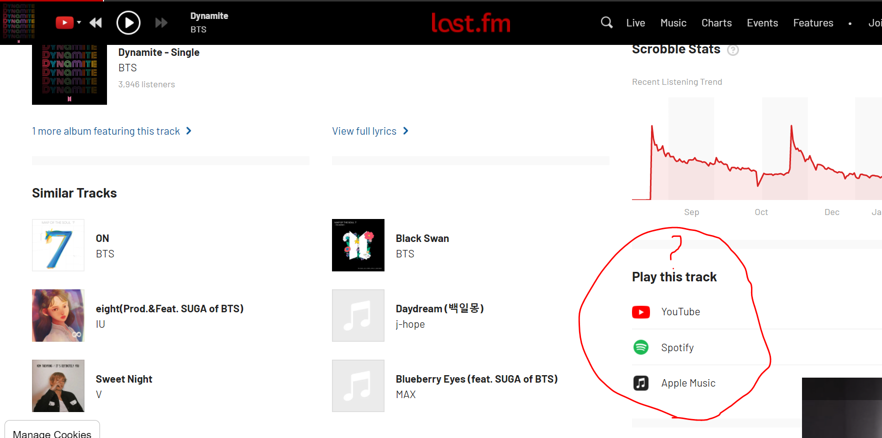
- “Playlist” app discovered by Sarah
Technology
- Everything
- Can we or the platform/ singer keep track of shares or clicks on our platform?

